<http://php.net/manual/en/index.php>

<https://www.w3schools.com/php/default.asp>



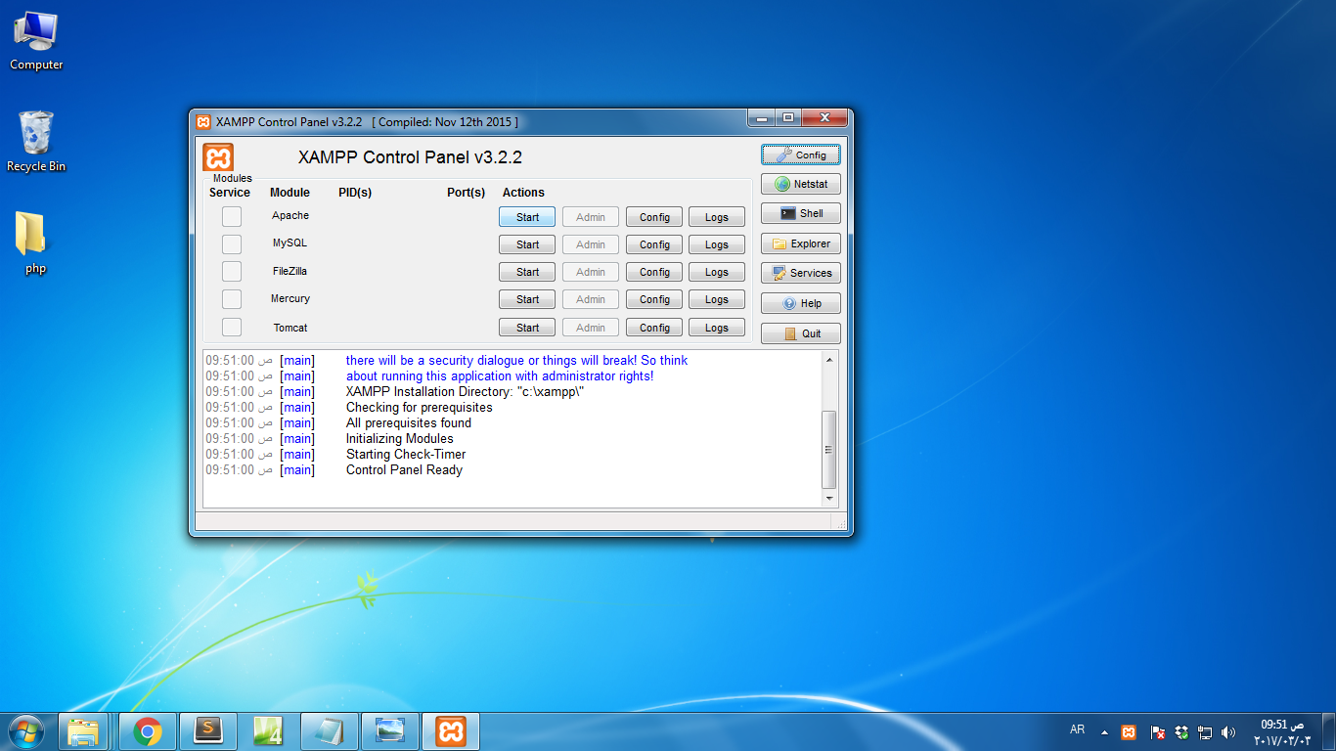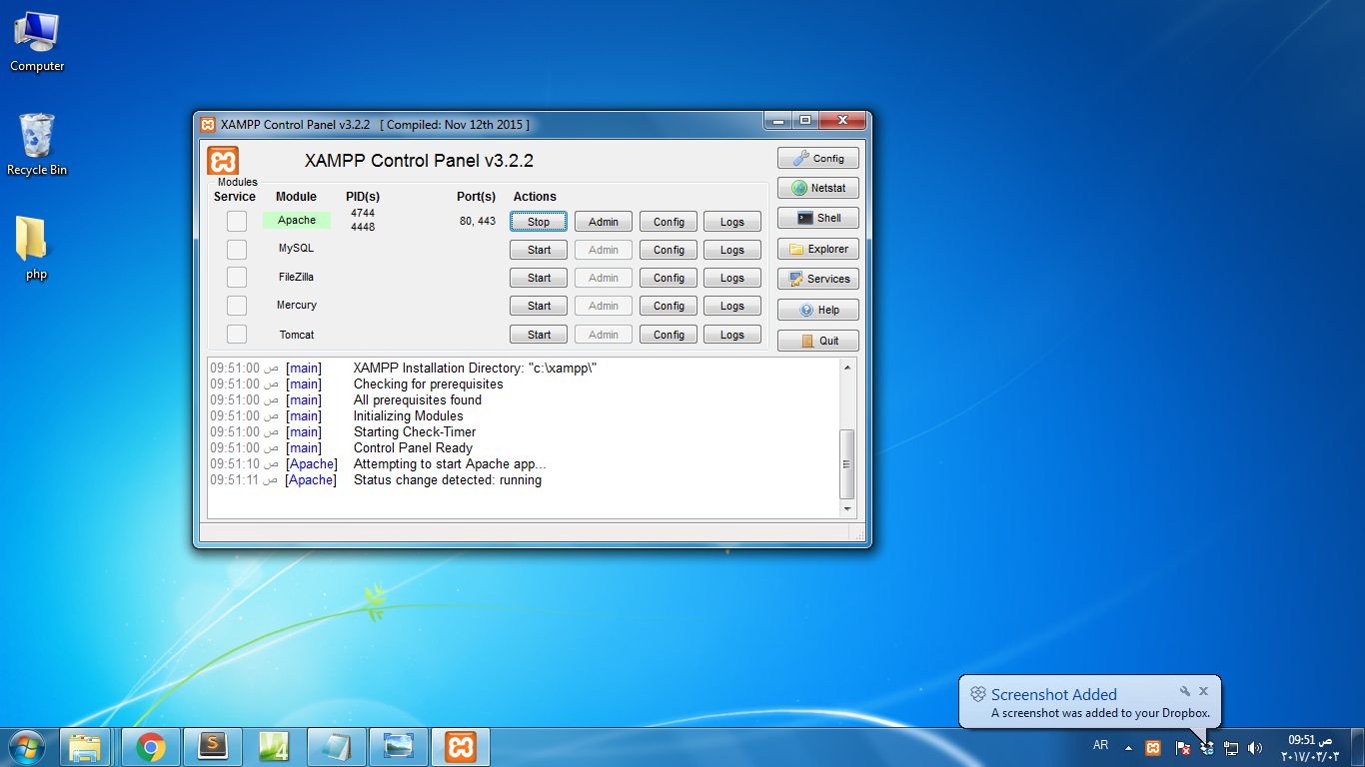

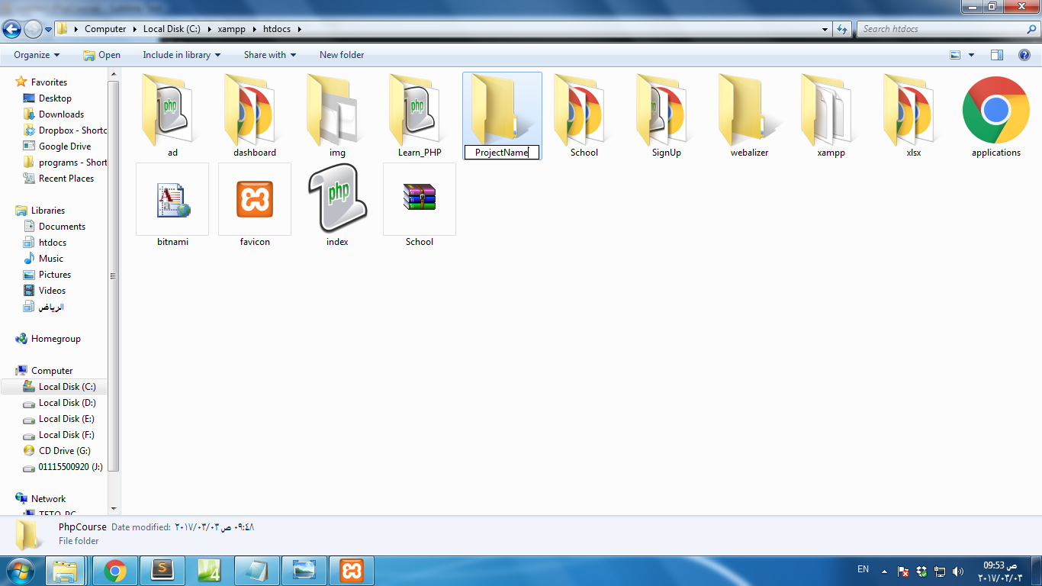



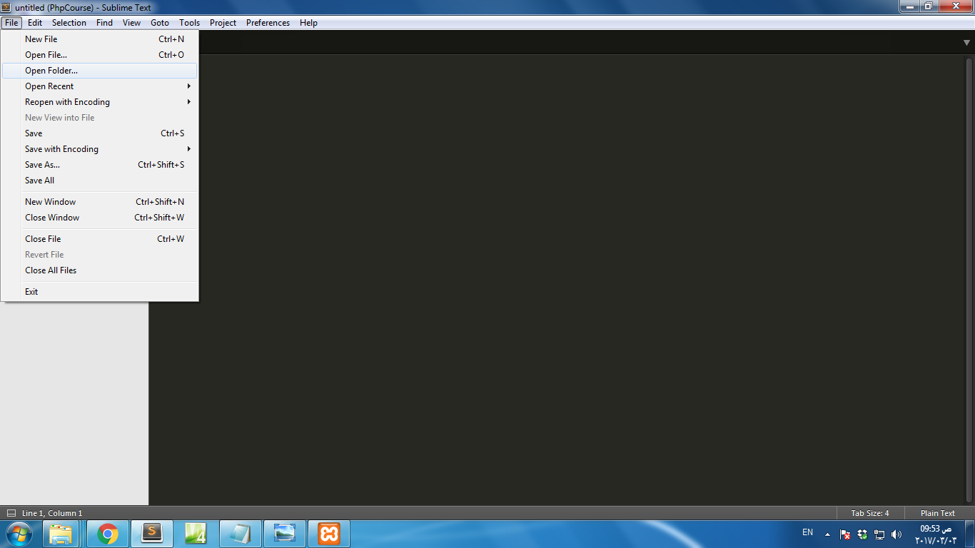

* Variable
  + **NULL** is_null()
  + **Scalar** is_ Scalar()
    - Boolean $x = true; is_bool()
    - String $x = "RTC"; is_string()
    - **Number** is_numeric()
      * Integer $x = 5; is_int()=is_Integer()=is_long()
      * Float=double $x = 5.5; is_float()=is_double()=is_real()

* + **Composed**
    - Array array("Volvo","BMW","Toyota"); is_array()
    - Object is_object()
* Constants define(*name*, *value);* define("*name*");
* session

session_start();  
$_SESSION["favcolor"] = "green";